Institution Setup

At the moment, this is how the setup looks, you can only select one examination type per institution name and code.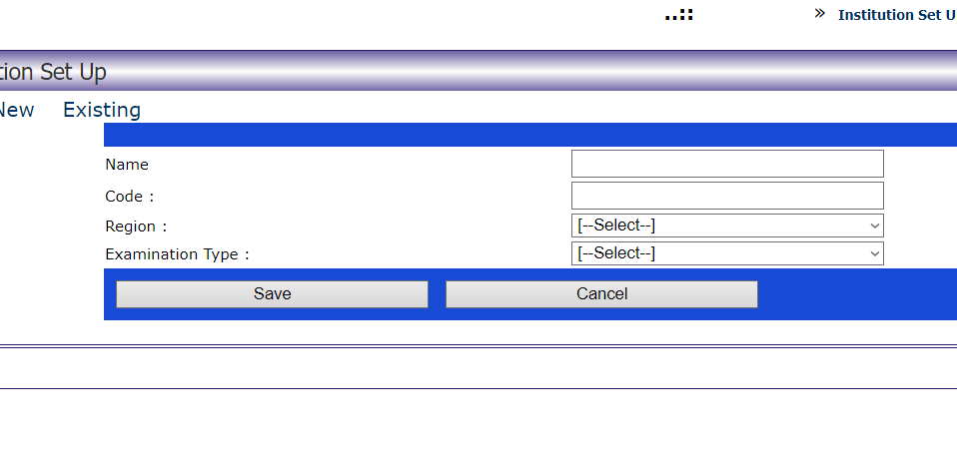

Instead of a dropdown, I’ll suggest checkboxes for multiple selections of Examination Types

